PROJECT DOCUMENTATION
SALARY SURVEY ON INDUSTRY USING EXCEL & MYSQL

Title | SALARY SURVEY
Name | ABDUL KADHAR M
Course | DADS
Batch | JULY 2025

TABLE OF CONTENT

SL.NO | CONTENT
1. | Project Objective
2. | Dataset Description
3. | Data Cleaning Process (Excel)
4. | Uploading Cleaned Data to MySQL
5. | SQL Queries for Analysis
6. | Exporting Query Results to Excel
7. | Pivot Tables and Dashboard Creation
8. | Insights & Summary
9. | Conclusion

INTRODUCTION
This project explores the transformation of a raw salary survey dataset into a structured, analysis-ready resource capable of powering meaningful insights about compensation trends across industries, job roles, experience levels, education, and demographics. Beginning with a 1,000-record Excel file containing inconsistencies, missing values, mixed currencies, and formatting issues, the workflow guides the data through a complete cleaning process. The refined dataset is then loaded into MySQL, where analytical SQL queries uncover patterns and correlations. These results are exported to Excel and transformed into pivot tables and an interactive dashboard that visually communicates the story behind the numbers. By the end of the project, the dataset evolves from a noisy spreadsheet into a polished analytical asset suitable for HR analytics, workforce planning, and compensation benchmarking.
AIM OF THE PROJECT
The aim of this project is to transform an unclean salary survey dataset into a structured, accurate, and insightful analytical resource prepared for database storage, SQL-based exploration, and interactive dashboard visualization.
- PROJECT OBJECTIVES
The Main objectives of the project include:
- Cleaning and preparing the raw salary dataset by addressing missing values, inconsistent formats, mixed currencies, and outliers.
- Standardizing the data to ensure accuracy and consistency across all fields.
- Importing the cleaned dataset into a MySQL database and designing an appropriate table structure.
- Executing analytical SQL queries to uncover trends in salary, experience, gender, education, and job roles.
- Exporting query outputs and organizing them into Excel sheets for visualization.
- Developing pivot tables and a comprehensive dashboard to present findings clearly.
- Delivering insights and conclusions that support further analytics and decision-making.
PROJECT WORKFLOW
- Data Inspection: Review the unclean Excel dataset for missing values, inconsistencies, duplicates, and mixed data types.
- Data Cleaning: Handle missing values, standardize text, correct data types, resolve currency variations, and remove duplicates.
- Outlier Detection: Identify unusual salary entries and validate or remove them.
- Dataset Preparation: Finalize the cleaned sheet and export it as CSV for further processing.
- MySQL Integration: Create a database and table, then import the cleaned dataset for structured storage.
- SQL Analysis: Execute 10 key analytical SQL queries to extract insights related to salary, gender, education, job roles, experience, and geography.
- Data Export: Save each query result as a separate CSV file and import into Excel.
- Pivot Tables & Dashboard: Build pivot tables and create an interactive dashboard to visualize findings.

- DATA UNDERSTANDING
To understand the structure and nature of the salary survey dataset, key aspects were analyzed before beginning data cleaning:
- Data Structure Overview
- The dataset includes 1,000 employee entries with demographic, salary, and job-related information.
- Contains both numerical and categorical fields.
- Variable Types
- Numerical: Annual Salary, Additional Compensation, Years of Experience.
- Categorical: Industry, Job Title, City, Country, Gender, Education Level, Age Range.
- Currency field contains mixed currency types (USD, INR, EUR, GBP, etc.).
- Completeness Check
- Several missing values were identified across numerical and categorical fields.
- Additional compensation had undefined or missing values in many rows.
- Consistency Issues
- Inconsistent naming patterns in Job Titles and Industries.
- Mixed casing (uppercase, lowercase, title case).
- Extra spaces and spelling variations.
- Outliers and Anomalies
- Salary and compensation fields contained unusually high or low entries.
- Years of experience showed some unrealistic values.
- Data Quality Observations
- Duplicate rows existed across Name, Job Title, and City combinations.
- Some numerical columns were stored as text.

- DATA CLEANING PROCESS (EXCEL)
Step 1: Inspect the Dataset
- Scanned for missing values, inconsistent spellings, outliers, mixed currency formats, and duplicates.
- Created a backup sheet before editing.
Step 2: Handle Missing Values
- Numerical columns: removed rows with very few missing values or filled with mean/median.
- Categorical columns: replaced blanks with "Unknown" or "Not specified".
Step 3: Standardize Text
- Used Find & Replace to unify industry names.
- Applied PROPER() or LOWER() for casing.
- Cleaned extra spaces using TRIM().
Step 4: Remove Duplicates
- Used Data → Remove Duplicates.
- Validated using a helper column combining Name, Job Title, and City.
Step 5: Correct Data Types
- Ensured salary fields were numeric using VALUE() or Paste Special → Multiply.
Step 6: Handle Mixed Currencies
- Chose USD as the base currency.
- Created Salary_USD using: Annual Salary / Conversion Rate.
Step 7: Detect and Handle Outliers
- Used Conditional Formatting to highlight extreme salary values.
- Verified valid cases (e.g., senior executives) and removed obvious errors.
Step 8: Save Cleaned Dataset
- Created a new sheet "Cleaned_Data".
- Copied values (Paste Special → Values).
- Exported as Salary_Survey_Cleaned.xlsx and CSV.
Step 9: Prepare Data for MySQL
- Ensured clean column names and formatting.
- Saved final CSV for import.
FIGURE:
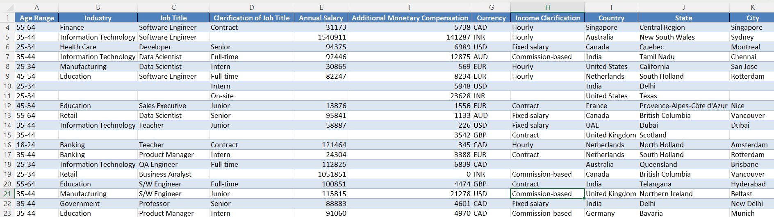
Figure 1: Raw Uncleaned Dataset
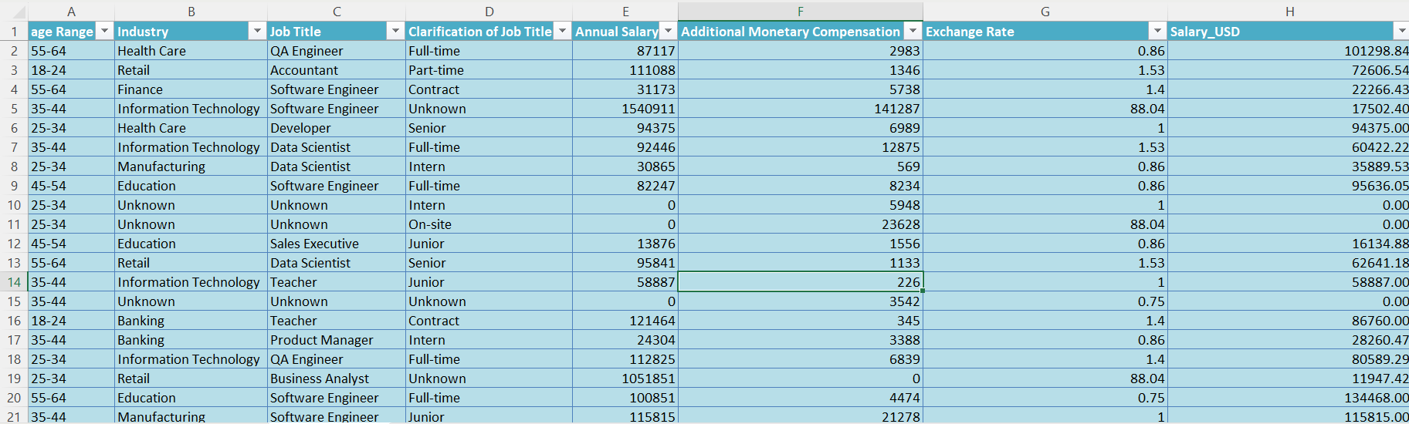
Figure 2: Cleaned Dataset
- Upload Data to MySQL
Step 1: Create Database
- Create a dedicated MySQL database to store cleaned salary data.
- Ensures organized storage and easier management for SQL analysis.
- Switch to the new database for all further operations.
SQL Code
CREATE DATABASE salary_survey;
USE salary_survey;
Step 2: Create Table
- Design a table structure that matches the cleaned dataset.
- Assign proper data types (INT, DECIMAL, VARCHAR, etc.).
- Ensures accuracy when storing salaries, categories, and text fields.
Step 3: Import the CSV
- Import the cleaned dataset into the table.
- Use MySQL Workbench Import Wizard or LOAD DATA INFILE.
- Moves the dataset into a structured environment for efficient querying.
FIGURE:

- SQL QUERIES FOR ANALYSIS
Average Salary by Industry and Gender
- Compares salaries between genders within each industry.
- Helps identify potential pay gaps or equality trends.
Total Compensation by Job Title
- Combines base salary and additional compensation.
- Highlights the highest-paying job titles overall.
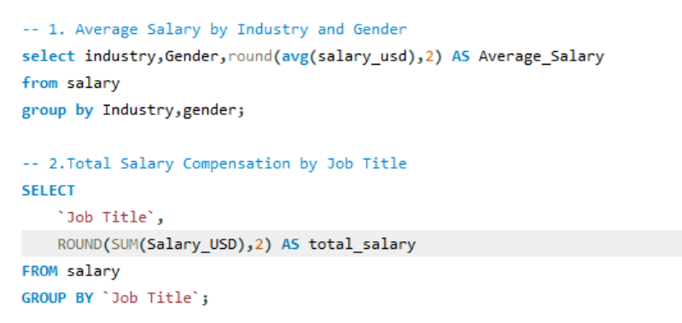
Salary Distribution by Education Level
- Shows how education influences pay ranges.
- Useful for analyzing salary progression across qualifications.
Number of Employees by Industry and Experience
- Counts employees grouped by experience within each industry.
- Reveals which industries employ more senior or entry-level talent.
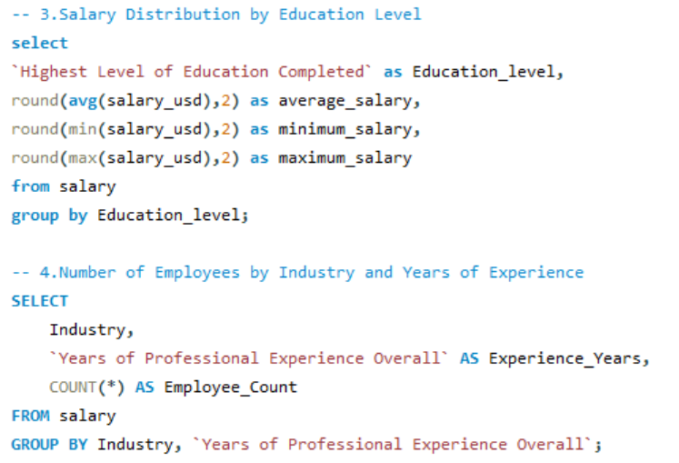
Median Salary by Age Range and Gender
- Provides stable comparison using median instead of average.
- Highlights salary differences across age groups and genders.
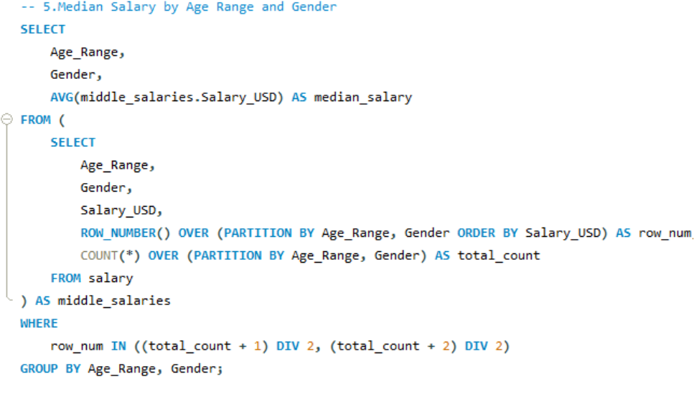
Highest-Paying Job Titles in Each Country
- Lists the highest-earning roles by country.
- Useful for comparing global or regional compensation trends.
Average Salary by City and Industry
- Shows how salaries vary by city within industries.
- Identifies high-paying cities or regions.
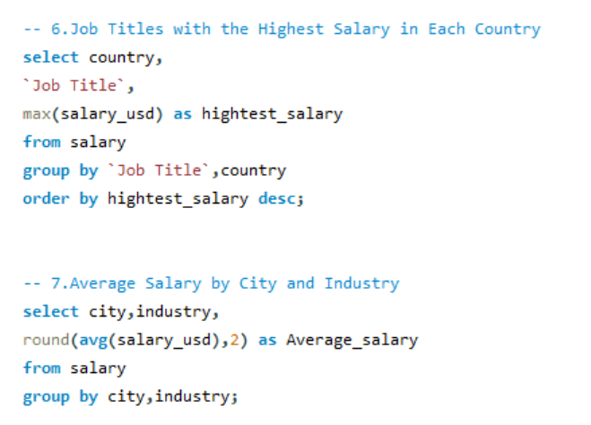
Percentage of Employees Receiving Additional Compensation by Gender
- Measures bonus or incentive distribution across genders.
- Helps evaluate fairness in reward systems.
Total Compensation by Job Title and Experience Level
- Shows compensation growth as experience increases.
- Useful for career progression and salary forecasting.
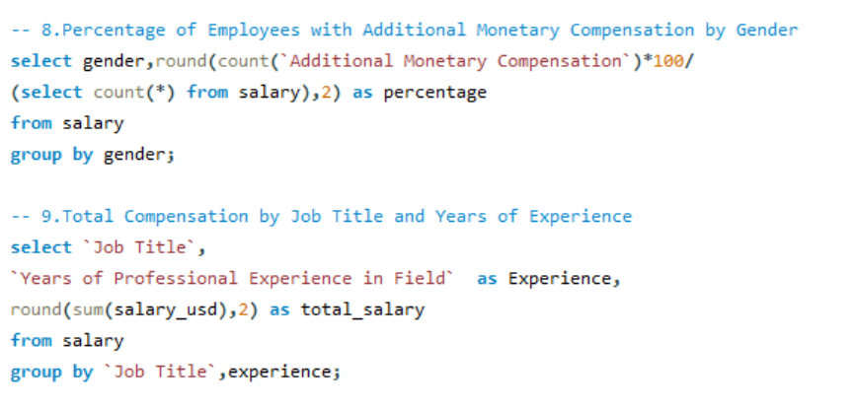
Average Salary by Industry, Gender, and Education
- Combines multiple factors for a deeper cross-sectional analysis.
- Helps understand how education and gender influence pay within industries.
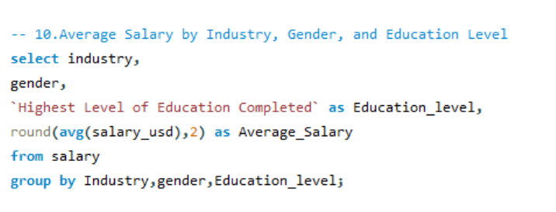

- EXPORT QUERY TO EXCEL
Run SQL Queries
- Execute each of the 10 analytical SQL queries in MySQL Workbench.
- Verify results for accuracy and completeness before exporting.
Export Each Result as a CSV File
- Use the MySQL Workbench “Export Resultset” option.
- Save each output as a separate CSV file (e.g., Query1_Industry_Gender.csv).
- This keeps analysis organized and easy to import into Excel later.
Create an Excel Workbook
- Open a new Excel file to store all query outputs.
- Name the workbook appropriately (e.g., Salary_Analysis_Queries.xlsx).
Import Each CSV into Separate Sheets
- Import each CSV file into its own sheet within the workbook.
- Rename sheets clearly (e.g., Industry_Gender, JobTitle_Compensation, Education_Salary, etc.).
- Ensure data loads correctly without formatting issues.
Verify Data Formatting
- Check for column alignment, data types, and missing fields.
- Format salary and compensation columns as numeric values.
- Apply filters for easy navigation.
Prepare Sheets for Pivot Tables
- Ensure each sheet is clean, with no merged cells or blank header rows.
- Data should be in a continuous table-like structure for smooth pivot table creation.
FIGURE:
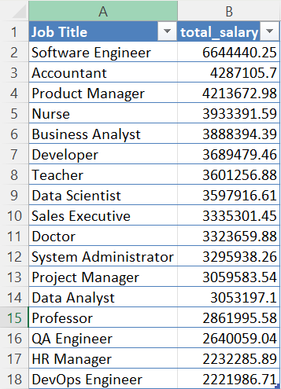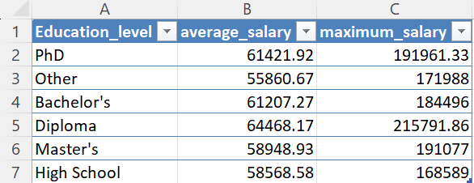
Figure 3: Query Table in Excel Worksheet - 1 Figure 4: Query Table in Excel Worksheet - 2
PIVOT AND DASHBOARD
Create Pivot Tables
- Select the imported query sheets and insert Pivot Tables for analysis.
- Use the appropriate fields (Rows, Columns, Values, Filters) to summarize the data.
- Create separate pivot tables for salary, compensation, job titles, industries, experience, and gender.
- Ensure that each pivot table gives a clear summary suitable for visualization.
FIGURE
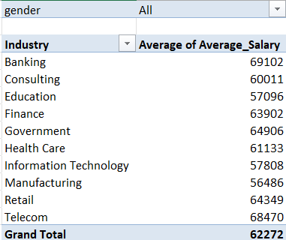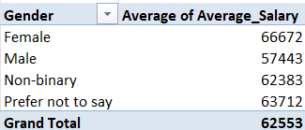
Figure 4: Avg. pay by Industry Figure 5: Avg. pay According to Gender
Build Visual Charts
- Convert key pivot tables into charts such as bar charts, column charts, pie charts, or line charts.
- Use chart types that best represent comparisons (e.g., bar chart for industries, column chart for job roles).
- Ensure axis labels, titles, and legends are clear and professional.
Create the Dashboard Sheet
- Add a new sheet named Dashboard to the Excel workbook.
- Arrange pivot charts and key tables in a clean, structured layout.
- Position visuals logically (i.e., high-level metrics at the top, detailed charts below).
- Maintain consistent formatting and color schemes across all visuals.
Add Interactivity
- Insert slicers for fields like Industry, Gender, Country, Job Title, or Education Level.
- Connect slicers to relevant pivot tables and charts for interactive filtering.
- Add timeline slicers for date fields if applicable (not mandatory for this dataset).
Final Formatting and Presentation
- Adjust chart sizes and alignment for a clean, polished look.
- Add titles, subtitles, and descriptive labels to improve readability.
- Use conditional formatting in pivot tables to highlight important values.
- Ensure the dashboard presents insights in a visually appealing and user-friendly manner.
FIGURE:
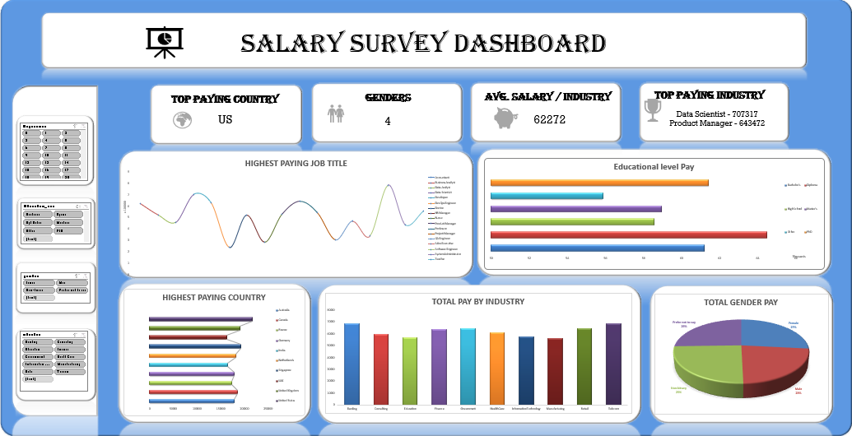
Figure 6: Interactive Dashboard
- INSIGHT

The salary survey analysis provides a comprehensive view of how compensation differs across industries, job roles, education levels, experience, and regions. The findings reveal clear trends that help organizations understand workforce dynamics and make informed decisions about pay structures and equity.
Industries such as Technology, Finance, and Consulting show consistently higher average salaries, reflecting strong demand and competitive markets. Job titles involving leadership or technical specialization earn the most, highlighting the premium placed on expertise and responsibility. Education level is positively correlated with earnings, where professionals with advanced degrees tend to receive higher compensation.
Geographical patterns indicate that major cities and developed countries offer better salary packages compared to smaller towns or emerging markets. Experience remains a key determinant of pay, with seasoned professionals earning significantly more than entry-level employees.
Key Takeaways
- High-growth industries and specialized roles command premium salaries.
- Education and experience directly influence earning potential.
- Salary disparities exist across locations, with urban areas offering higher compensation.
- Insights from this analysis can guide fair pay practices, workforce planning, and strategic talent management.

- CONCLUSION

This project successfully transformed an unstructured salary survey dataset into a reliable, analysis-ready resource through a complete data cleaning, database integration, and visualization workflow. By addressing missing values, inconsistencies, duplicates, and mixed currencies, the dataset was standardized and prepared for structured analysis in MySQL. The use of SQL queries enabled the extraction of valuable insights into salary trends across industries, education levels, experience, and geographic locations. Exporting query results into Excel and visualizing them through pivot tables and dashboards allowed for a clear, interactive presentation of findings.

The project demonstrates how data-driven techniques can uncover hidden patterns, support equitable pay analysis, and aid in workforce strategy decisions. Overall, it highlights the importance of clean data, effective querying, and professional visualization in delivering actionable insights that support human resource analytics, compensation benchmarking, and strategic decision-making in business environments.

